Romania Map Graphical Representation & Search in MAP

**API:**

Need to install 3 dictionaries to run this script

sudo apt-get install python3-tk (Python internal)

pip install network (External)

pip install matplotlib (External)

**Woking Procedure:**

* You will find a folder named app. Inside the app folder there are python script.
* You will find graph representation, BFS, DFS and IDS hard code inside the graph.py script
* To represent the graph, you have to run map_gui.py
* When you run the map_gui.py you will find 2 options
  + Represent the Romania map in GUI.
  + Search in Romania MAP.
* When you choose Represent the Romania map in GUI by pressing 1 then the Romania MAP will be represented as per assignment given picture
* Then when you choose Search in Romania MAP by pressing 2 then it will automatically ask to select algorithm from BFS DFS and IDS.
* After that you have to choose algorithm any of above three by pressing 1 or 2 or 3.
* Then you will be asked to select start city from 19 cities numbered sequentially
* Finally, when you select any of the city from 19 cities then it will automatically show starting to destination path, path cost and visited path using the selected algorithms.

**Results:**

Represent the Romania map

In the result you will be able to see Romania map as per your given figure. Node name, marking, path connection and cost functions are included in the figure

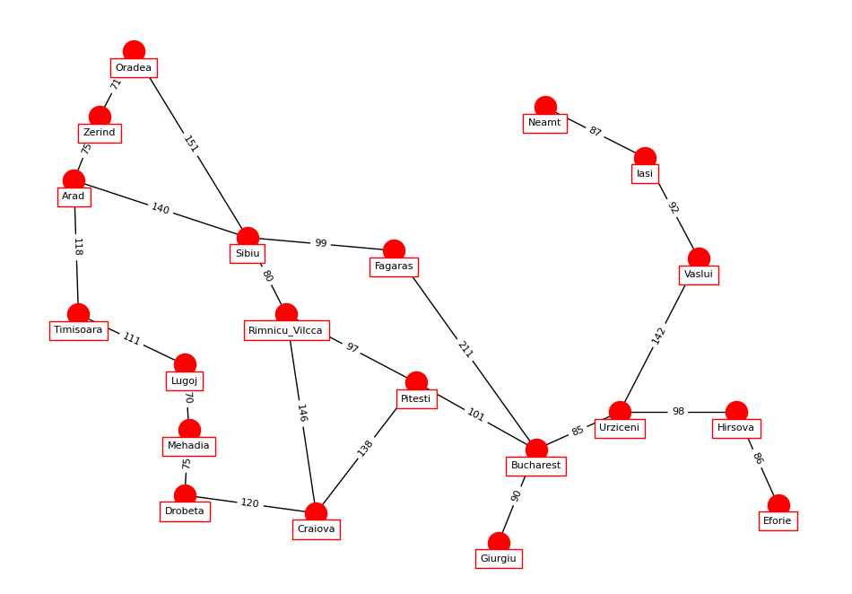

**Search in Romania MAP**

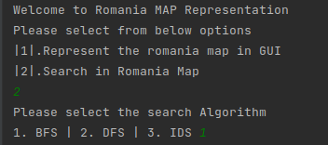

**BFS**

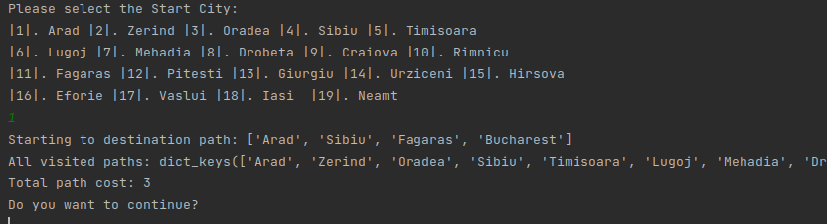

**DFS**

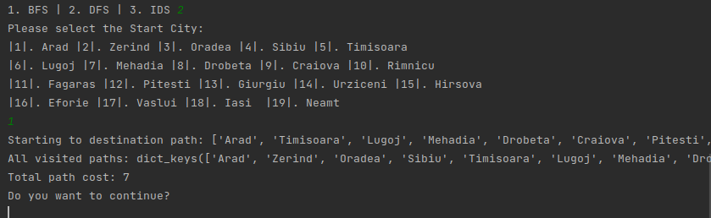

**IDS**

